**Integrating Azure Key vaults and service principal methods in Devops Automation build Tool:**

**Step 1. Please refer below document for Azure AD application registration and key vaults in Azure :**



**Step 2. Using Key vaults in devops:**

1.Need to Login to Azure subscription account and create Key vaults as shown in below :

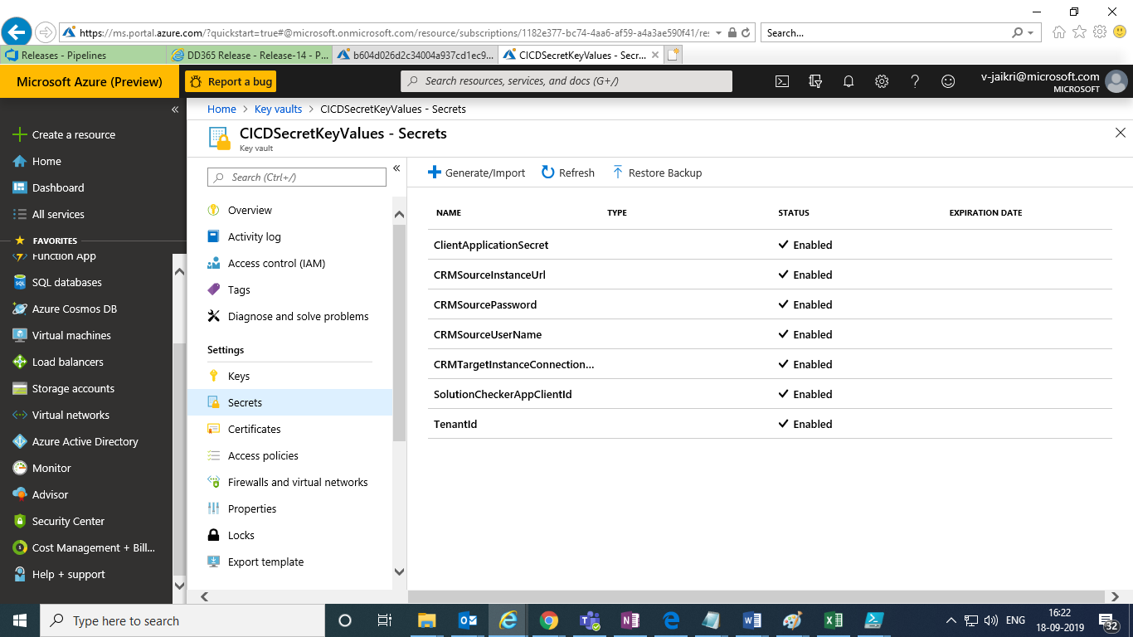

2.Login to Azure devops and click on project settings:

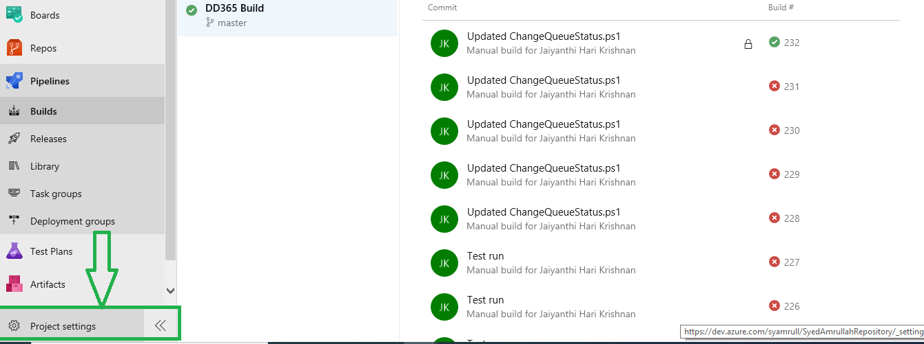

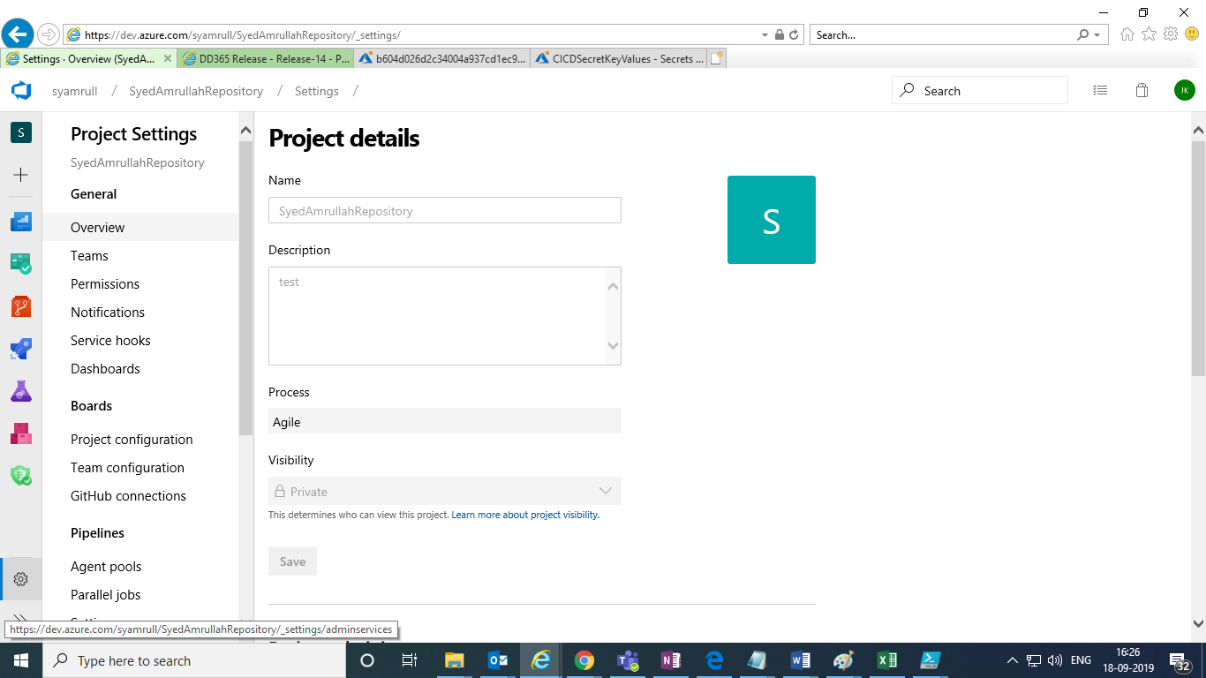

3.click on service connections in project settings blade ,

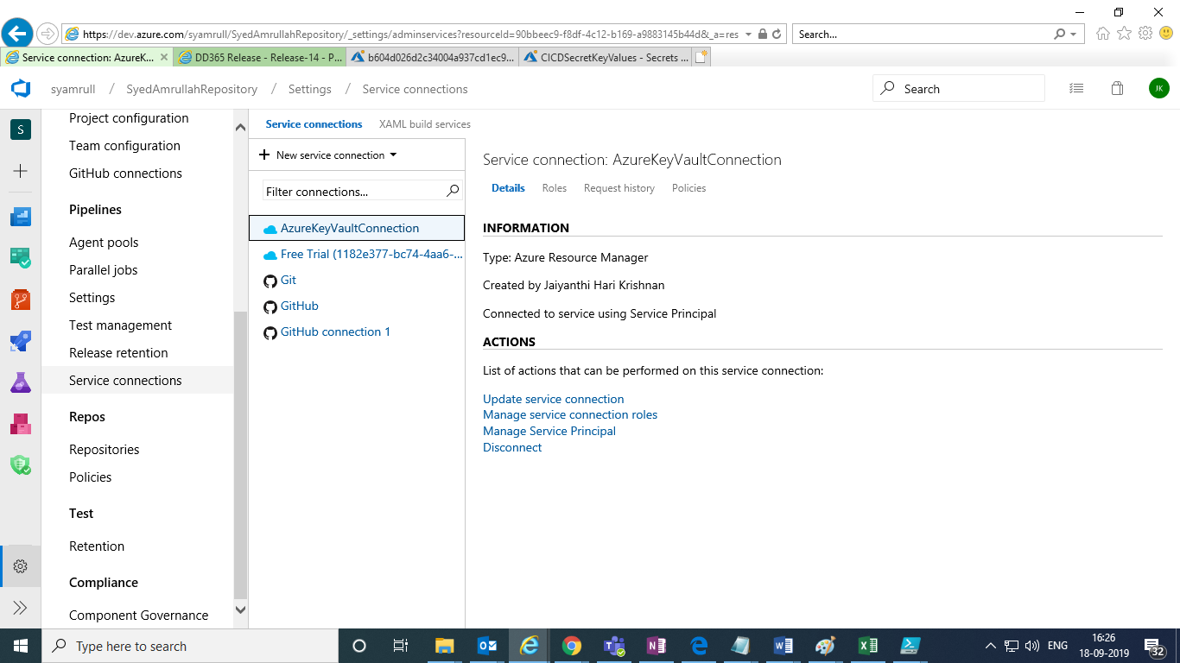

4.click on + New service connection in above screen ,

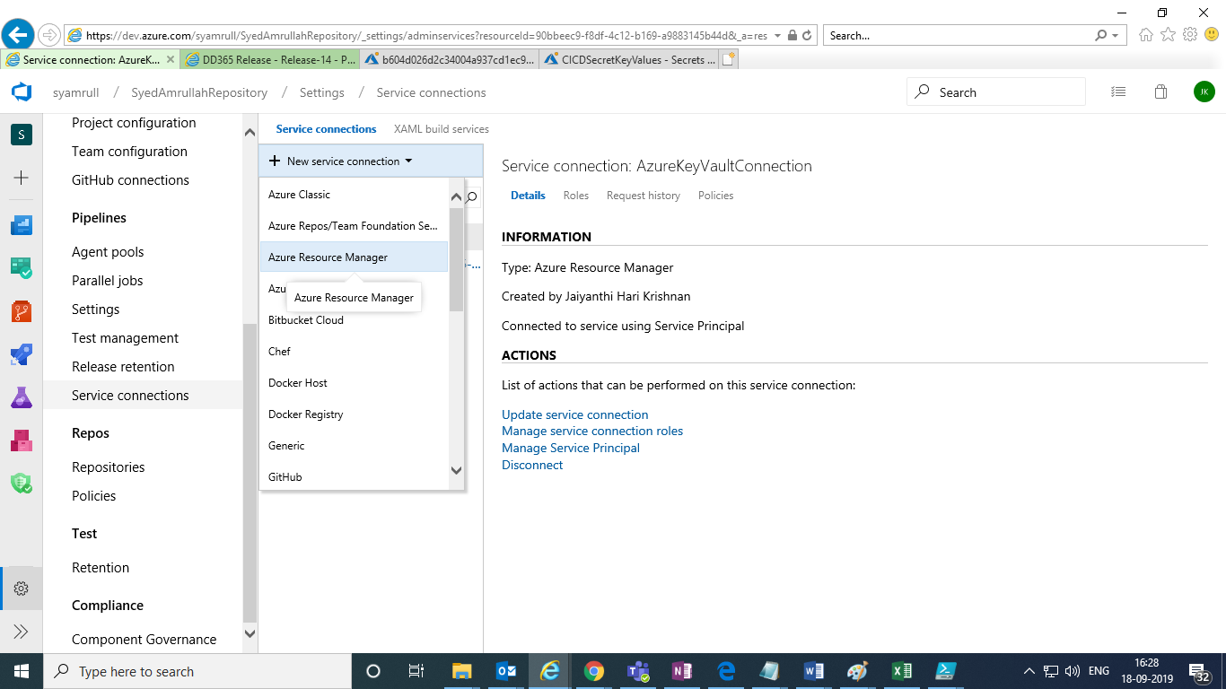

5.select Azure Resource Manager type and give details :



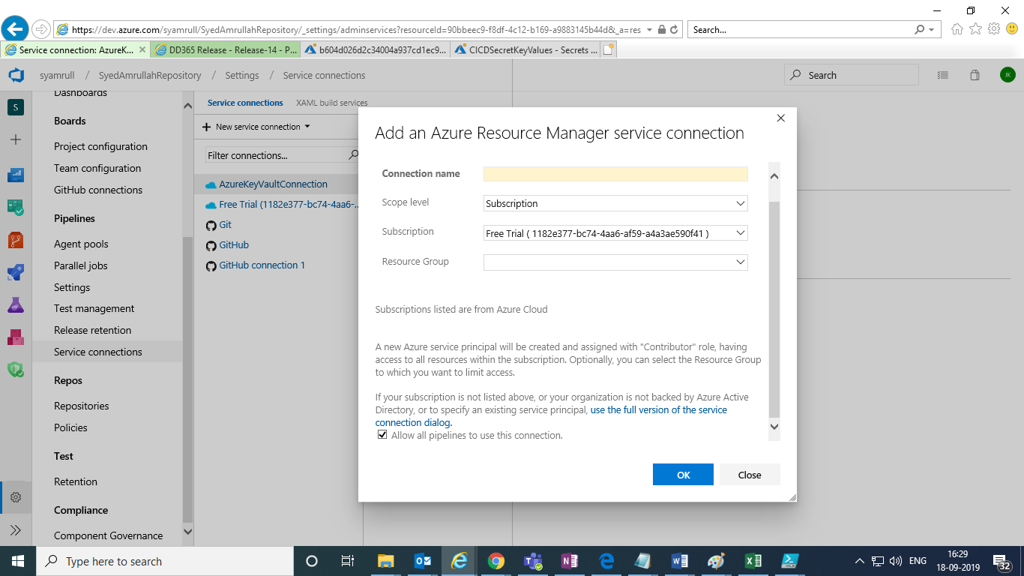

6.Give details in above screen and click on OK and once created it will show under service connections :

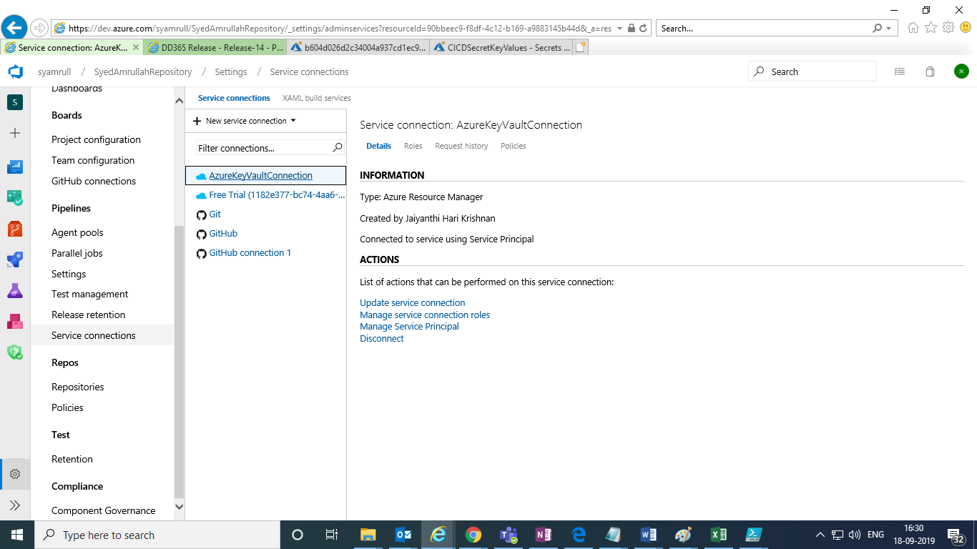

7.Now go back to the build pipeline and create variable group.

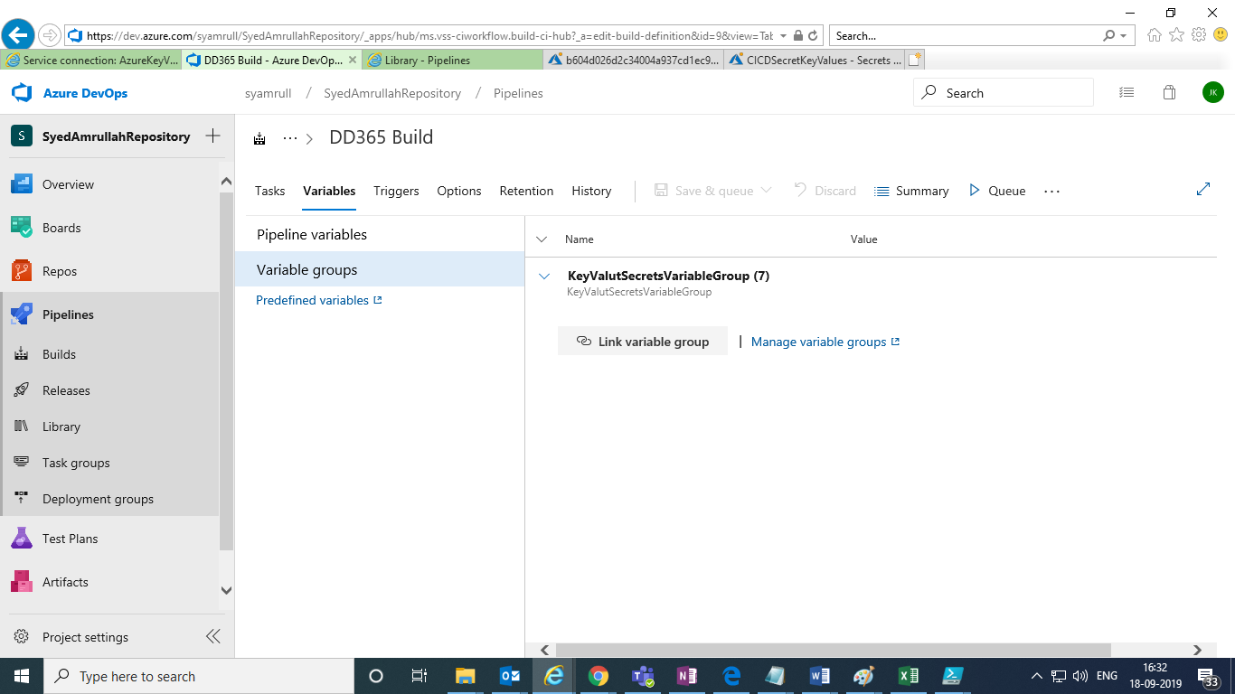

Click on manage variable groups :

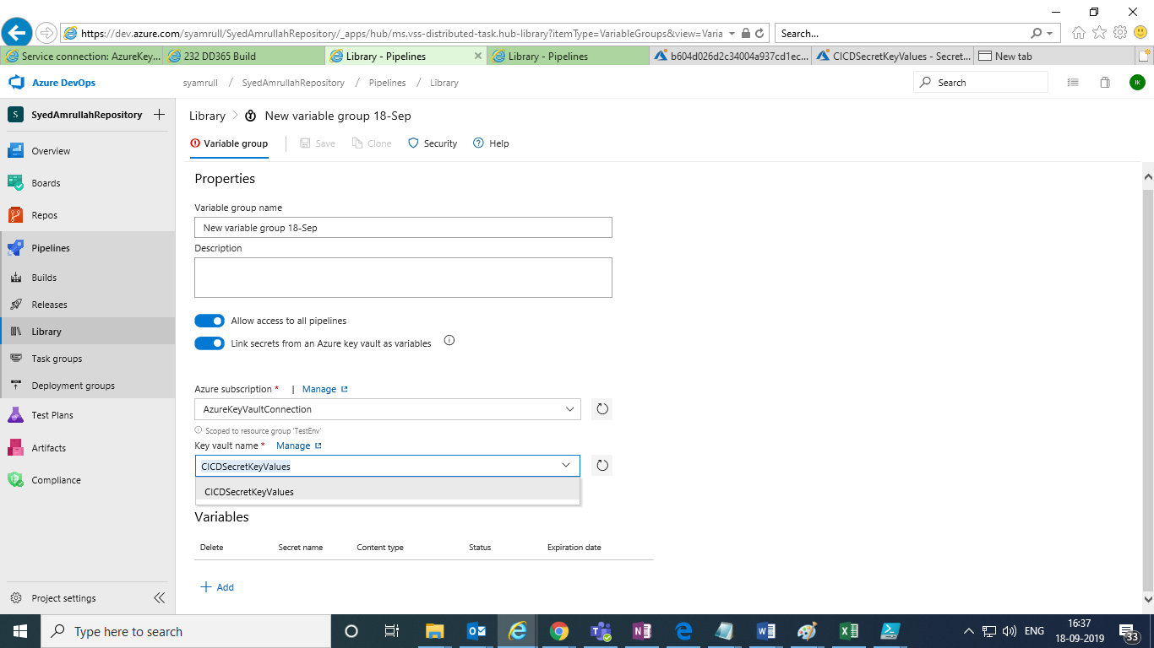

Give values and select the service connection which we recently created in the azure subscription.

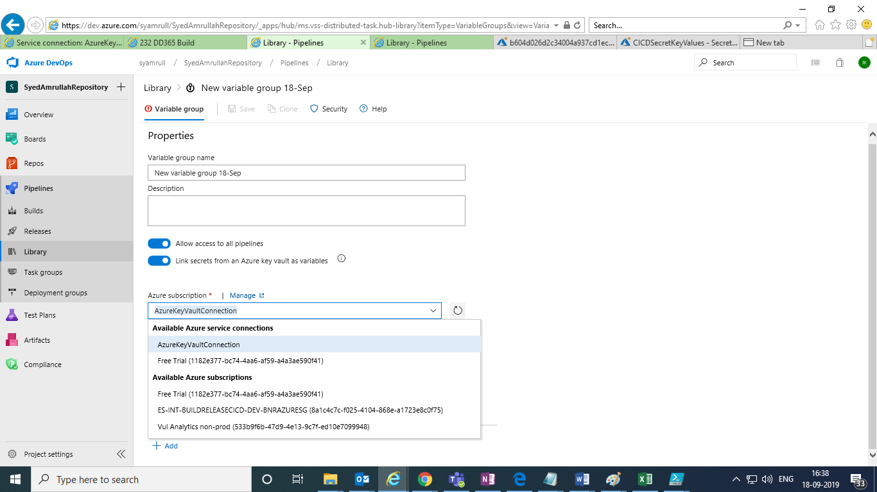

Click on Add to add the secrets values to group,

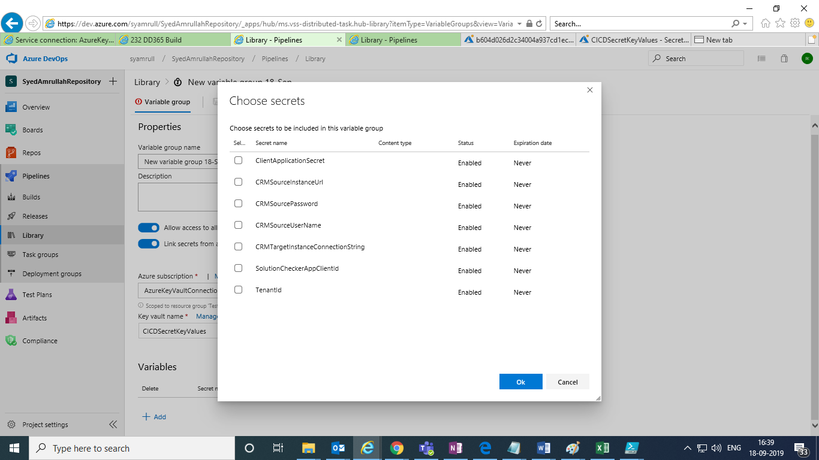

Need to choose the secrets and click on **OK**,

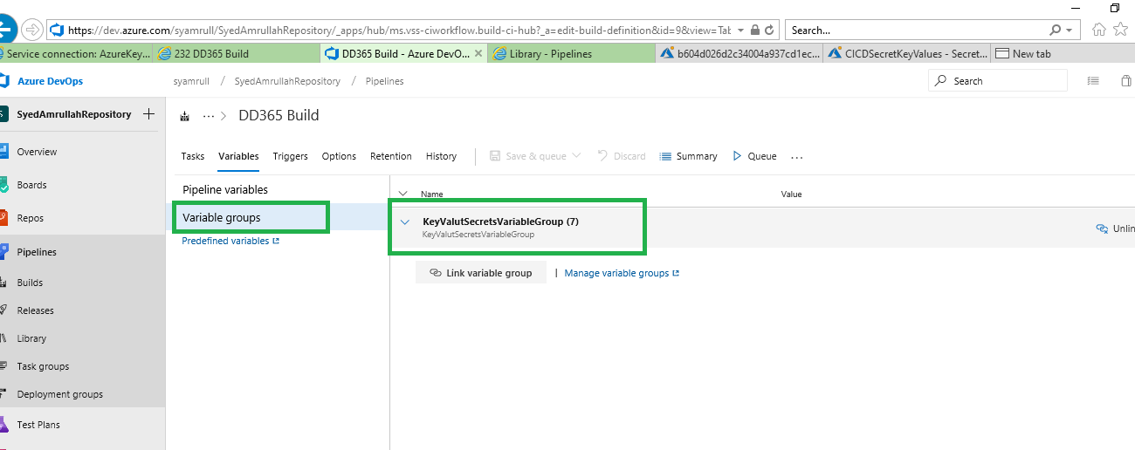

After variable creation we need to link variable group to Build pipeline, click on **Link variable Group** in the above screen.

8.Now go to Tasks where we want to use these keyvault and use them in $(KeyvaultSecretName) format , it will get the value from keyvaults and store it in that variable.

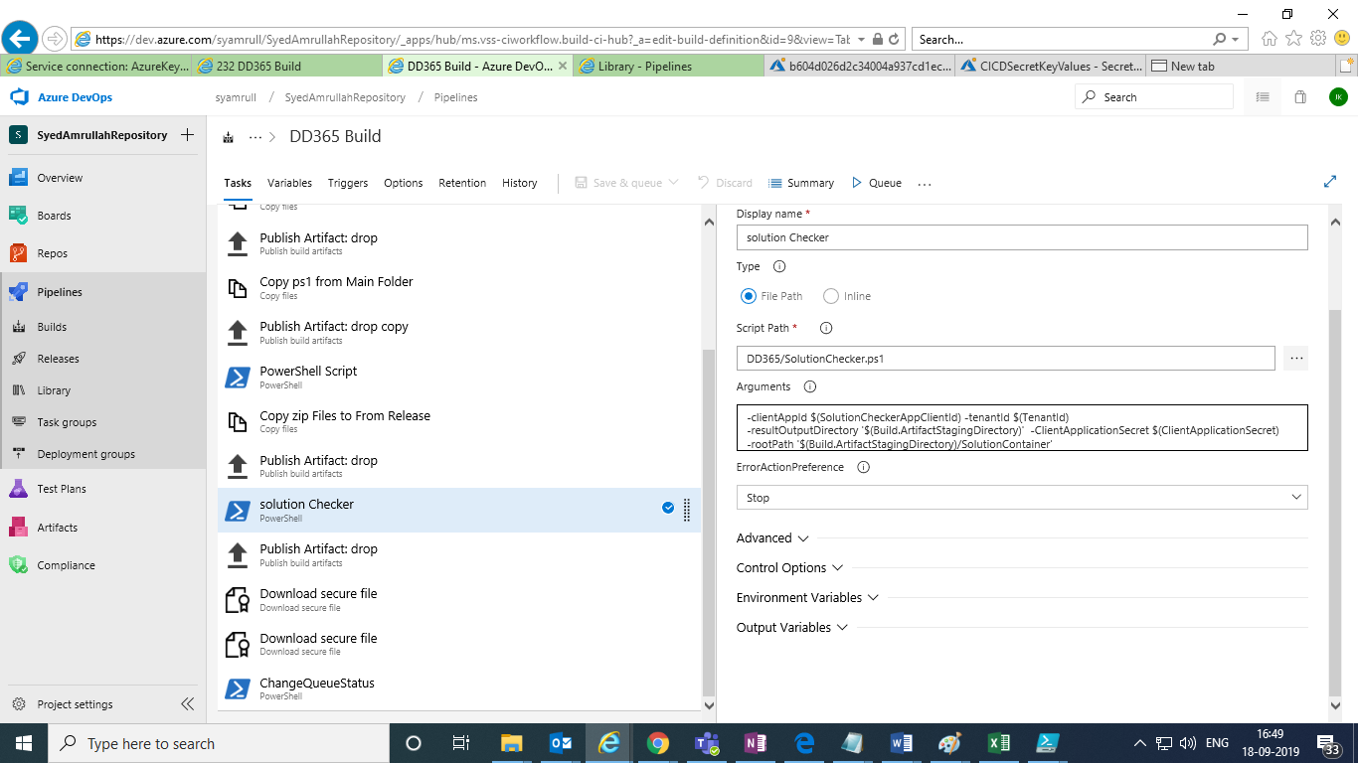

In parameters we can pass like :

-clientAppId **$(SolutionCheckerAppClientId)** -tenantId **$(TenantId)** -resultOutputDirectory '$(Build.ArtifactStagingDirectory)' -ClientApplicationSecret **$(ClientApplicationSecret)** -rootPath '$(Build.ArtifactStagingDirectory)/SolutionContainer'

And in powersghell script :

Param([string] $clientAppId,

[string] $tenantId,

[string] $solutionFileDirectory,

[string] $resultOutputDirectory,

[string] $ClientApplicationSecret

)

Etc…

Please refer below link for the same .

<https://daniel-krzyczkowski.github.io/How-to-inject-Azure-Key-Vault-secrets-in-the-Azure-DevOps-CICD-pipelines/>